Synthetica


Project Supervisor: Mr. Hassan Ayaz

Group Members:

Muhammad Bilal Rehan

Muhammad Sufyan

Uzair ghani

Muhammad Uzair

Umer Yasir

(ICT) Session 2023-2026

Construction Technology Training Institute, Islamabad

1. FRONT MATTER
1.1 Roles
- Uzair ghani: dataset collection and organizing
- Muhammad Uzair and Umer Yasir: backend, frontend and database
- Muhammad Bilal & Muhammad Sufyan: Model Training, AI Inference, and Signal Processing Logic

1.2 Supervisor
- Mr. Hassan Ayaz (ICT Department, CTTI)

1.3 Declaration
We hereby declare that this project, "Synthetica," is our own work and has not been submitted previously for any other degree or diploma. All external libraries and datasets have been properly cited.
1.4 Abstract
The rapid advancement of Generative AI has led to a proliferation of highly realistic synthetic media. Traditional detection models often function as "black boxes," providing binary classifications without explainable evidence. This project presents Synthetica, a comprehensive platform designed to detect manipulated media with high accuracy and transparency. By fine-tuning the Xception Convolutional Neural Network (CNN) on a massive master dataset of 239,000 images, the system achieved a validation accuracy of 98.46%. To ensure zero latency and data privacy, the system utilizes a fully localized architecture hosted at verifexapp.com.

2. CHAPTER 1: INTRODUCTION

1.1 Problem Statement
The democratization of AI through tools like Midjourney and Stable Diffusion has created a "post-Truth" era. Traditional software cannot distinguish between authentic photos and synthetic ones. For DAE students, IT professionals, Media and Cybersecurity firms this represents a critical infrastructure vulnerability where misinformation can be weaponized. Synthetica addresses this by providing a "Glass-Box" approach to AI—showing not just the verdict, but the evidence.

1.2 Aims and Objectives
- High-Fidelity Detection: Achieve >98% accuracy using depth-wise separable convolutions.
- To implement a Triple-Tier Forensic Pipeline (Metadata, AI, and Signal Math).
- Explainability: Implement Grad-CAM to highlight exactly where the AI sees "fakeness."
- Cross-Platform Accessibility: Deploy a user-friendly full-stack web-based tool via verifex.org.
- Zero Latency: Use a localized architecture for model inference to prevent API delays.
- Robust cloud database system: To design a robust, persistent database system to store uploaded images, probability scores, explanations, and timestamps for record-keeping.

1.3 Features of Project
- Concrete Functionalities: Provides modular forensic operations including metadata interrogation, Xception-based neural inference, and frequency signal analysis for comprehensive image validation.
- Efficiency and Accuracy: Optimized for high-speed local processing, achieving a validated 98.46% detection accuracy with results delivered in under two seconds.
- Web Services: Employs HTTP protocols and JSON data exchange between the Flask backend and Convex cloud database for seamless real-time synchronization.
- Desktop and Android Availability: Features a responsive web architecture that ensures full functionality across both desktop and Android devices with universal account synchronization.

3. CHAPTER 2: Model Training

2.1 Dataset Aggregation
We moved beyond small academic datasets. Our system was trained on an aggregated master-set:
- Deepfake-vs-Real (20k): High-quality GAN faces.
- Hard-Fake Challenge Set: Images specifically designed to trick AI.
- Custom 200k Dataset: Scraped AI-generated visuals.
- Quarantine Process: Using a custom script, we purged 404-error images and corrupted headers before training began.

2.2 Pre-processing & Quarantine
- Corrupted File Purge: Every image was passed through img.verify() to remove files corrupted during download.
- Deduplication: An MD5 hashing script was used to remove duplicate images across merged datasets, ensuring a clean 50/50 balanced split between 'Real' and 'Fake' categories.

2.3 Model Selection: Xception
We selected Xception (Extreme Inception) because it uses Depthwise Separable Convolutions. Instead of looking at the whole image at once, it maps spatial correlations and cross-channel correlations separately. This makes it significantly better at finding "unnatural" pixel patterns in synthetic skin and hair.
Xception++ Architecture and Mathematical Functions
Overview
This document expands on the key features mentioned in the presentation, specifically detailing the second model, the Xception++ Neural Core, and the underlying mathematical functions used to calculate the final forensic verdict.
1. The Xception++ Neural Core
The system utilizes the Xception (Extreme Inception) architecture as its core AI detection model. It was specifically selected for its superior ability to analyse synthetic media and deepfakes.
- Depthwise Separable Convolutions: Instead of processing the whole image at once, the Xception model maps spatial correlations and cross-channel correlations separately. This makes it significantly better at finding "unnatural" microscopic pixel patterns (e.g., in synthetic skin, textures, and hair) compared to standard CNNs.
- Two-Phase Training Pipeline:
  - Phase 1 (Feature Extraction): The base layers of the Xception model were initially frozen, and only custom dense output layers were trained. This preserved the model's pre-trained ability to recognize fundamental visual geometries.
  - Phase 2 (Fine-Tuning): The entire architecture was unfrozen and a low learning rate was applied. This allowed the network to adapt specifically to the microscopic frequency artifacts unique to GAN-generated images.
- Explainable AI (Grad-CAM Heatmaps): To move beyond standard "black box" binary detection, the model uses Grad-CAM to compute the gradient of the output with respect to the last convolutional layer. It produces visual heatmaps where red areas indicate high manipulation suspicion, explicitly proving where and how an image was manipulated.
2. Refined Mathematical Functions & Sovereign Balanced Ensemble (SBE)
To ensure a highly robust final verdict, the system does not rely solely on the AI model. Instead, it utilizes a Sovereign Balanced Ensemble (SBE) that combines the AI prediction with strict mathematical logic and signal processing techniques.
The final verdict is calculated using the following mathematical formula: Final Verdict = (Xception AI Score × 0.50) + (Frequency Domain Analysis × 0.25) + (Edge Consistency Logic × 0.25)
Breakdown of the Mathematical Components:
- Xception Neural Core (50% Weight): The base probability score generated by the Xception++ model, indicating the likelihood of the image being synthetic based on learned pixel patterns.
- Frequency Domain Analysis / FFT (25% Weight): AI-generated images often leave "high-frequency artifacts" in the spectral domain that are invisible to the human eye but mathematically obvious. Fast Fourier Transform (FFT) analysis is used to calculate and detect these synthetic frequency textures.
- Edge Consistency Logic / ELA (25% Weight): Compression algorithms (like those used by social media platforms) can obfuscate deepfake artifacts. Error Level Analysis (ELA) mathematically calculates compression variance across the image to detect edge inconsistencies. If the math detects extreme compression, it factors into this 25% weight and can dynamically append a reliability warning to the output.
3. Pipeline Integration
This mathematical ensemble operates dynamically within a multi-tiered pipeline. If the initial provenance check (Tier 1) flags an image as fake due to cryptographic signatures (C2PA) or metadata tags, the heavier mathematical computations and Xception++ inference are bypassed. When Tier 2 is triggered, the AI core, Frequency Math, and Edge Logic execute to compute the final weighted average and generate the forensic audit log.

4. CHAPTER 3: SYSTEM ARCHITECTURE & FLOW

3.1 Non-Face Content Filtering

To eliminate false positives from digital art and illustrations, a content-aware gate was implemented using MTCNN-based detection. If the system fails to detect a high-confidence human face, it automatically bypasses neural inference and classifies the content as "Non-Photographic." This ensures the Xception model only processes relevant photorealistic media.

3.2 Quality-Aware Reliability Logic

A forensic safeguard was added to address high-compression artifacts common in social media uploads (e.g., WhatsApp). The system utilizes Laplacian Variance to calculate image sharpness; if the quality falls below a safety threshold, an automated warning is issued to notify the user that forensic reliability may be reduced due to data loss.

3.3 Authentication & History Module
Instead of a standard SQL database, we used Convex.
- Why? Convex allows for real-time synchronization. When a user logs in, their scan history is fetched instantly without page reloads.
- Security: Authentication is handled via custom tokens, ensuring only authorized users can view their forensic audit logs.

3.4 The Forensic Pipeline (The "Double-Tier")
- Tier 1: Metadata Engine: Scans for "Software" tags (e.g., "Adobe Firefly") and C2PA cryptographic signatures.
- Tier 2: Xception Core and Frequency Analysis: The neural network predicts the likelihood of being fake based on learned patterns. Frequency analysis detects synthetic textures and edge inconsistencies. AI images often leave "high-frequency artifacts" in the spectral domain that are invisible to the human eye but obvious to our math engine.
note: If Tier 1 declares an image fake then Tier 2 gets ignored. Tier 2 only works when the images successfully pass the Tier 1 check.

3.5 Sovereign Balanced Ensemble (SBE)
The final verdict of Tier 2 is calculated using a refined mathematical weight:
- Xception Score: 35% weight
- Xception++ score: 35% weight
- Frequency Math: 10% weight
- Edge Consistency: 10% weight
- Noise: 10% weight
- Logic: Verdict = (AI * 0.7) + (Freq * 0.1) + (Edge * 0.1) + (Noise * 0.1)

3.6 Grad-CAM Module (Explainability)
Grad-CAM computes the gradient of the output with respect to the last convolutional layer. It produces a heatmap. Red areas indicate high manipulation suspicion
System Flow Chart
Below is the logical flow of the Synthetica system:
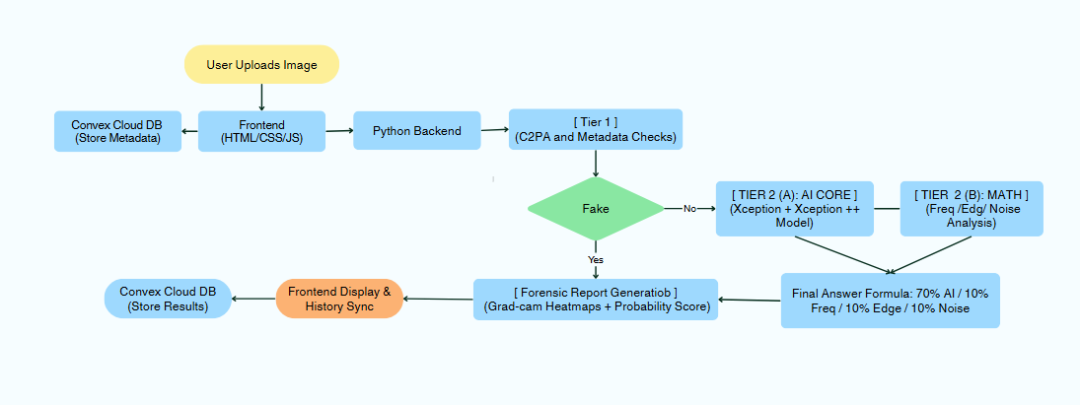
5. CHAPTER 4: TABLES, DIAGRAMS, AND INTERFACES
This chapter provides the technical blueprints of the Synthetica system. It includes the database schema designed for Convex, a formal Data Flow Diagram (DFD) illustrating how images are processed, and descriptions of the User Interfaces deployed at verifex.org.
- 4.1 Database Design (Convex Schema)
Unlike a standard relational database (SQL), Synthetica utilizes Convex, a cloud-native, document-oriented database. This allows for real-time synchronization of forensic reports across devices. The data is structured into "Documents" within specific collections.
Table 4.1: users Collection Schema
Field Name | Data Type | Description
_id | string | Unique identifier generated by Convex.
email | string | User’s registered email address (unique).
password | string | Hashed password for authentication.
createdAt | timestamp | Record creation time.
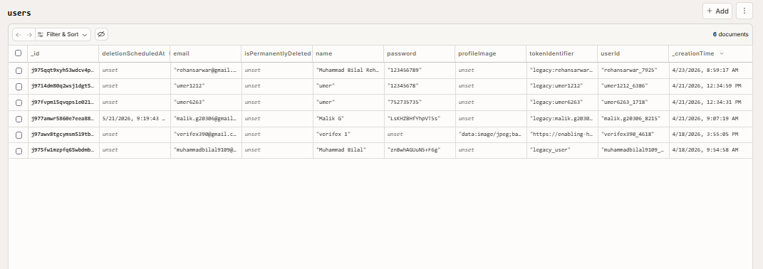
Table 4.2: scans Collection Schema
Field Name | Data Type | Description
_id | string | Unique identifier.
userId | string | Foreign key linking to the users collection.
scanId | string | Internal unique UUID for the forensic audit trail.
image | string (Base64) | The uploaded image stored as a Data URL for linked retrieval.
prediction | string | Binary verdict ("REAL" or "FAKE").
confidence | float | Final certainty score (e.g., 0.9846).
ensemble_p | float | Raw weighted probability from SBE (50/25/25 calculation).
audit_log | string | Full text-based Triple-Tier forensic interrogation log.
heatmap | string (Base64) | Score-CAM Grad-CAM generated visual heatmap.
timestamp | string | Time inference was completed.

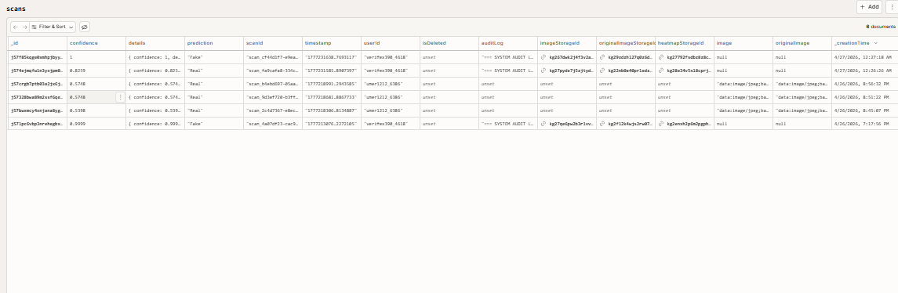
4.2 User Interface (UI) Descriptions
The user interface is designed using responsive web principles (RWA) to ensure it works flawlessly on both Desktop and Android browsers.
- Registration & Login Interface
A secure portal (Table 6.1 mapping) where users must create an account to access the forensic tools. This ensures that their scan history remains private and synchronized.
- The Scan Dashboard
The main interface where users can upload images via drag-and-drop. It features a progress bar that updates as the system moves through the Triple-Tier interrogation (Provenance -> Neural -> Signal).
- The Forensic Forensic Report (Verifex Report)
The final output screen after inference. It displays:
- Verdict: Big text ("REAL" or "FAKE").
- Confidence Gauge: A radial dial showing certainty.
- Explainable AI Heatmap: The original image overlaid with Grad-CAM red gradients highlighting AI suspicion areas.
- System Audit Log: A complete text breakdown showing the raw scores of each of the three independent forensic tests.

6. CHAPTER 5: SYSTEM FEASIBILITY

5.1 Technical Feasibility
The system is built using the Python/Flask ecosystem, which is highly compatible with AI libraries like TensorFlow and PyTorch. The localized inference approach ensures that the system does not depend on expensive third-party AI APIs.

5.2 Economic Feasibility
By utilizing open-source models and a custom-engineered dataset, the project eliminates ongoing licensing fees making the system economically viable for long-term use.

5.3 Behavioural Feasibility
The user interface is designed using modern web standards (HTML5/Bootstrap), requiring no technical expertise from the end-user. The inclusion of a "System Audit Log" helps users understand the "why" behind a verdict.

7. CHAPTER 6: SPECIFICATIONS & DEPLOYMENT

5.1 Recommended Hardware
- Training Phase: NVIDIA T4 Tensor Core GPU (via Google Colab).
- Inference Phase: Intel i5 or better with 8GB RAM.
- Storage: 2GB for Model Weights (.h5 file).

5.2 Recommended Software
- Python 3.10+ (Core Logic)
- TensorFlow/Keras (Deep Learning)
- OpenCV (Image Pre-processing)
- Node.js (Frontend Build tool)

5.3 Deployment Strategy (Hostinger & Verifex)
We deployed the system on Hostinger using the domain verifex.org. The architecture is "Integrated," meaning the Python Flask server runs as a background process while the frontend serves the user.

8. CHAPTER 7: CONCLUSION
Being DAE students at CTTI, this project allowed us to apply theoretical ICT knowledge to a real-world cybersecurity threat. Synthetica is more than just a website; it is a localized, sovereign forensic platform. We successfully transitioned from a local SQLite setup to a cloud-integrated Convex ecosystem, providing a professional-grade tool for the public.

9: CHAPTER 8: Future Scope
- Audio Forensics: Detecting voice clones.
- Browser Extension: Real-time checking of images as you browse.
- Decentralized Storage: Using IPFS for forensic reports.

